HOW TO GIVE RESHIP
STEP : 1
https://docs.google.com/forms/d/e/1FAIpQLSfQoGaKX7C8DFCpTuu3GCWbqCyinO1htTxT26jAoxIwrRfNBw/viewform Fill the form, keep employee name as yours (who is reshipping).
STEP : 2
Track the order using order id in the previous courier website, there reason will be mentioned. If no RTO reason is found, choose Reason unknown – but status RTO. If in the ticket customer mentioned any preferred courier partner mention them in notes saying that customer preferred them. At the last option CUSTOMER REASON, see if customer did mention anything specifically, otherwise choose not yet delivered.
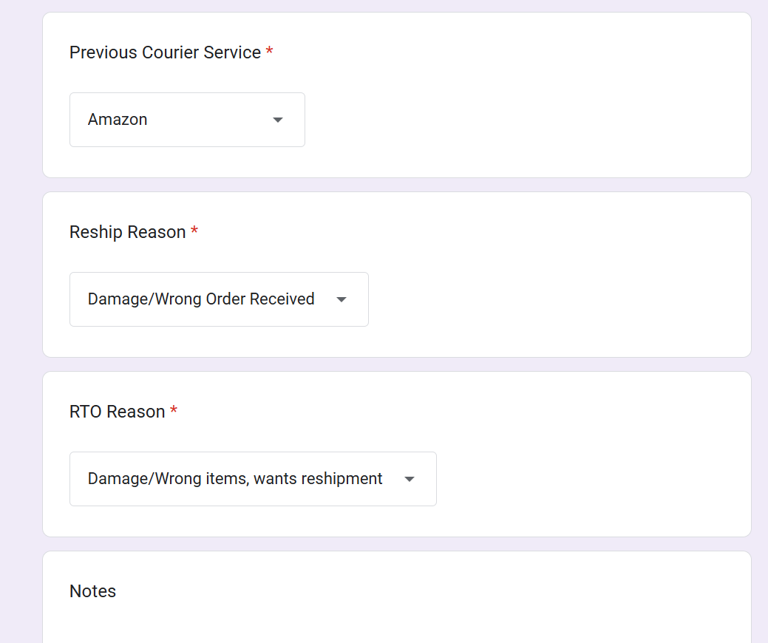
STEP : 3
Verify the final or updated address of customer matches with superapp shipping address or not. Click the eye icon in action to see the shipping address.
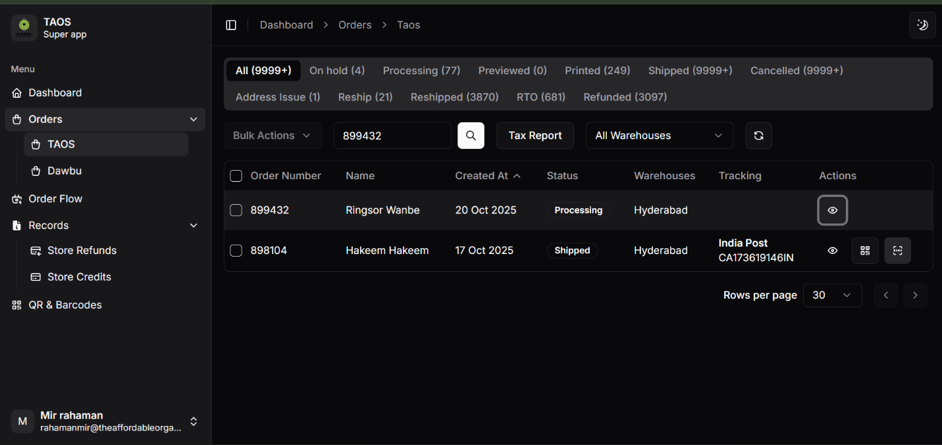
STEP : 4
If addresses do not match, change the shipping address of superapp to the updated one.
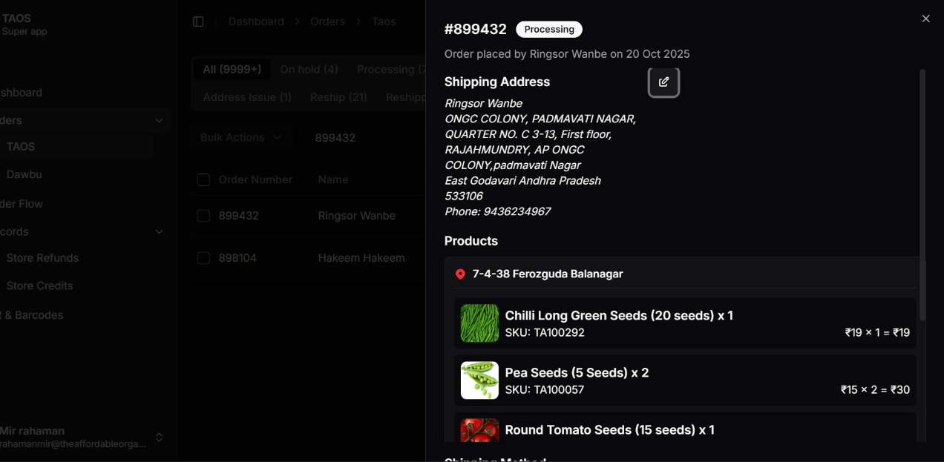

STEP : 5
Click the checkbox of particular order.
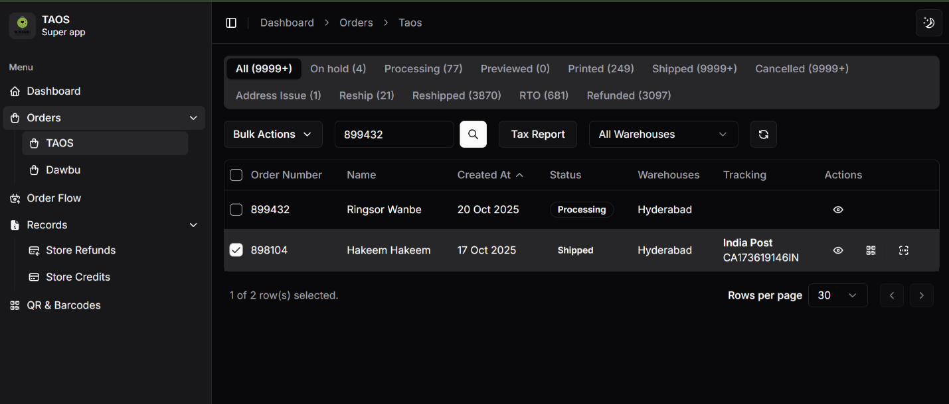
STEP : 6
Go to bulk action, then change status and then click Reshipped. Once updated, Status of the order should change to Reshipped.
STEP : 7
Go to Sagepilot. Go to canned response and type reship, then forward this mail.
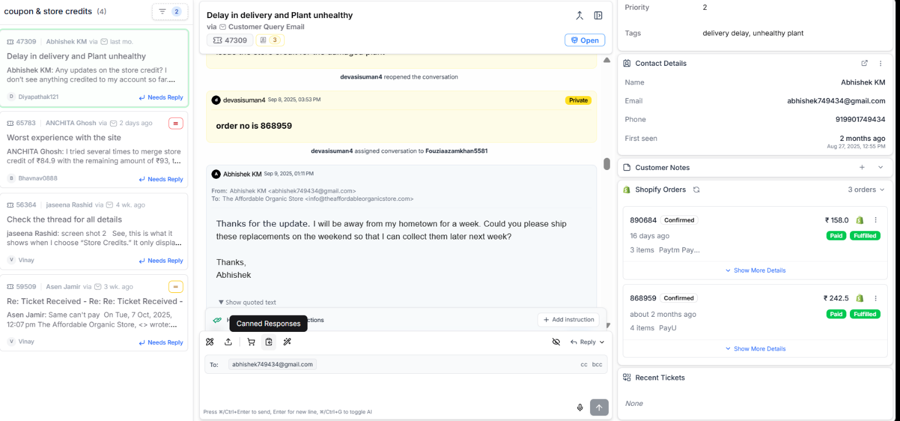

Dear [Customer Name],
We would like to inform you that we are proceeding with the reshipment of your order. You will receive all the tracking details shortly, once the shipment is picked up by our courier partner.
Thank you for your patience and understanding.
Warm regards,
[Your Name]

